Create Resource Group Name Vineela

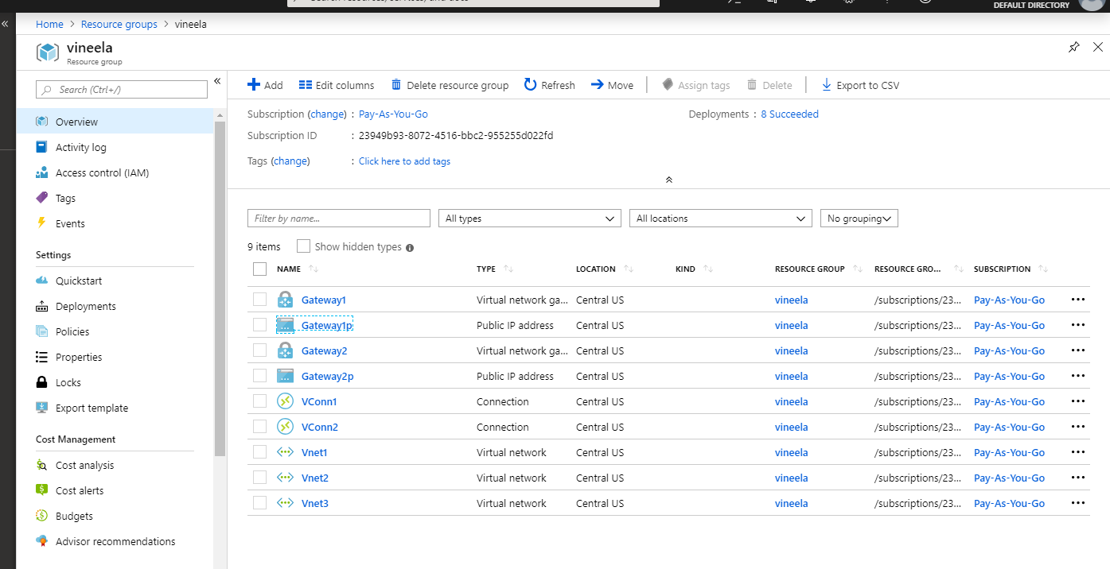

Create Vnet1

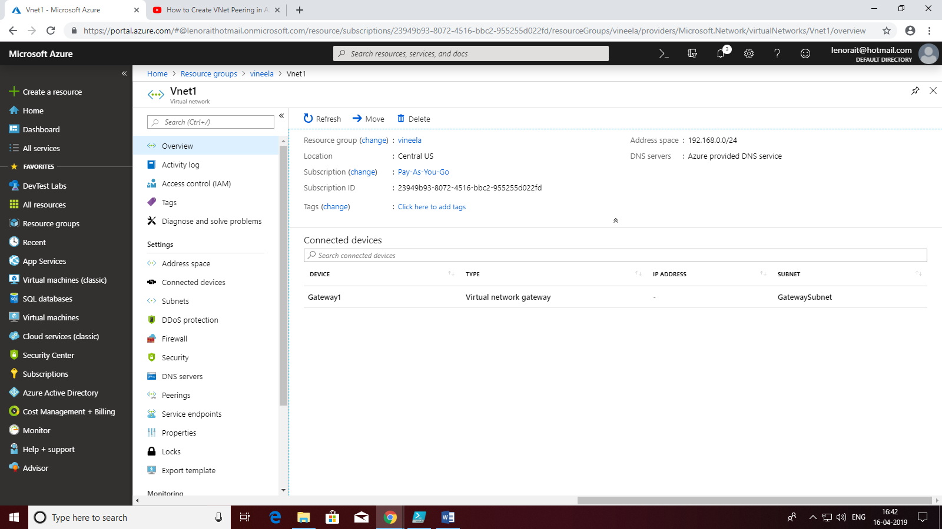

Create Vnet2

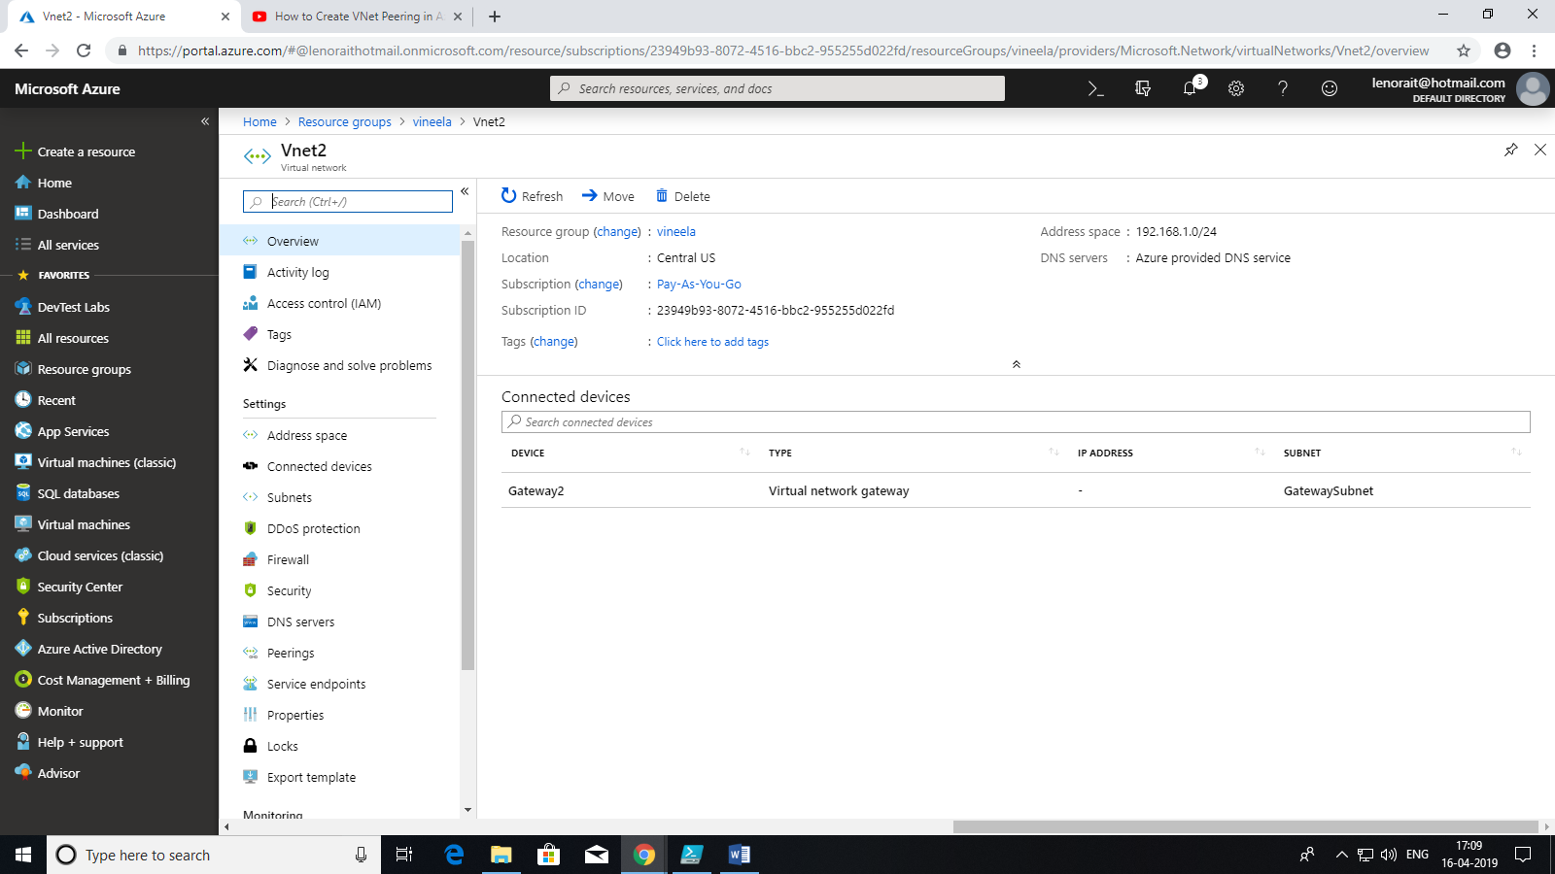

Create Vnet3

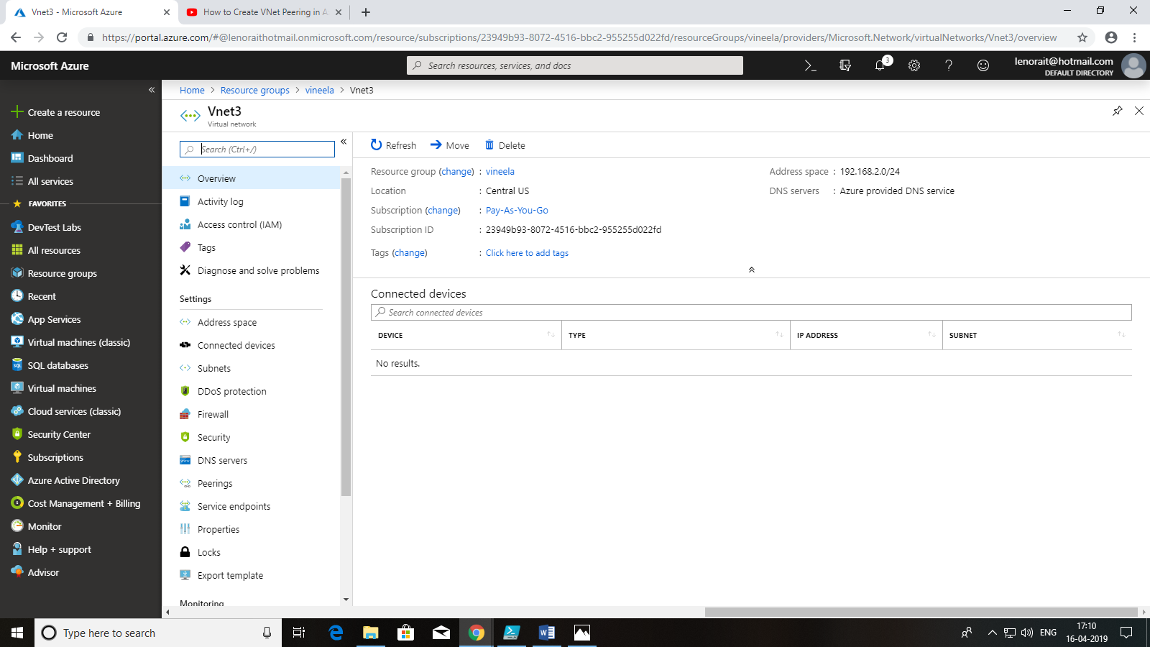

In Vnet1 Creating Subnets& Gateway Subnet

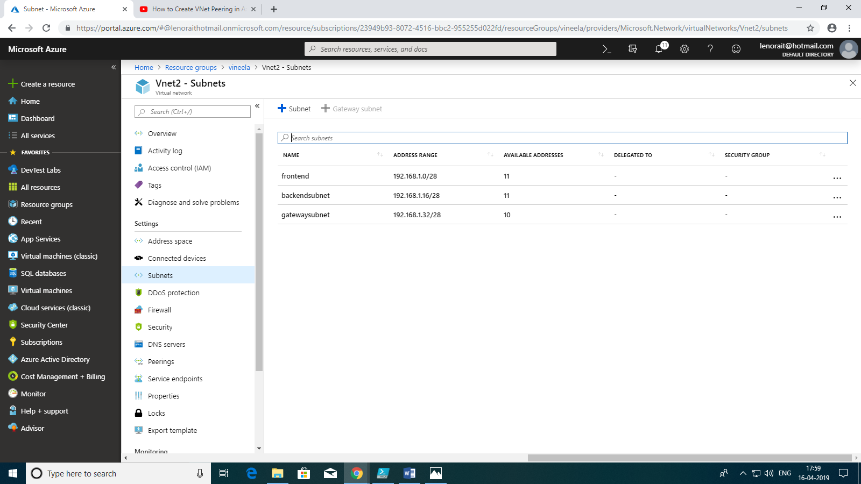

In Vnet2 Creating Subnets and Gateway Subnet

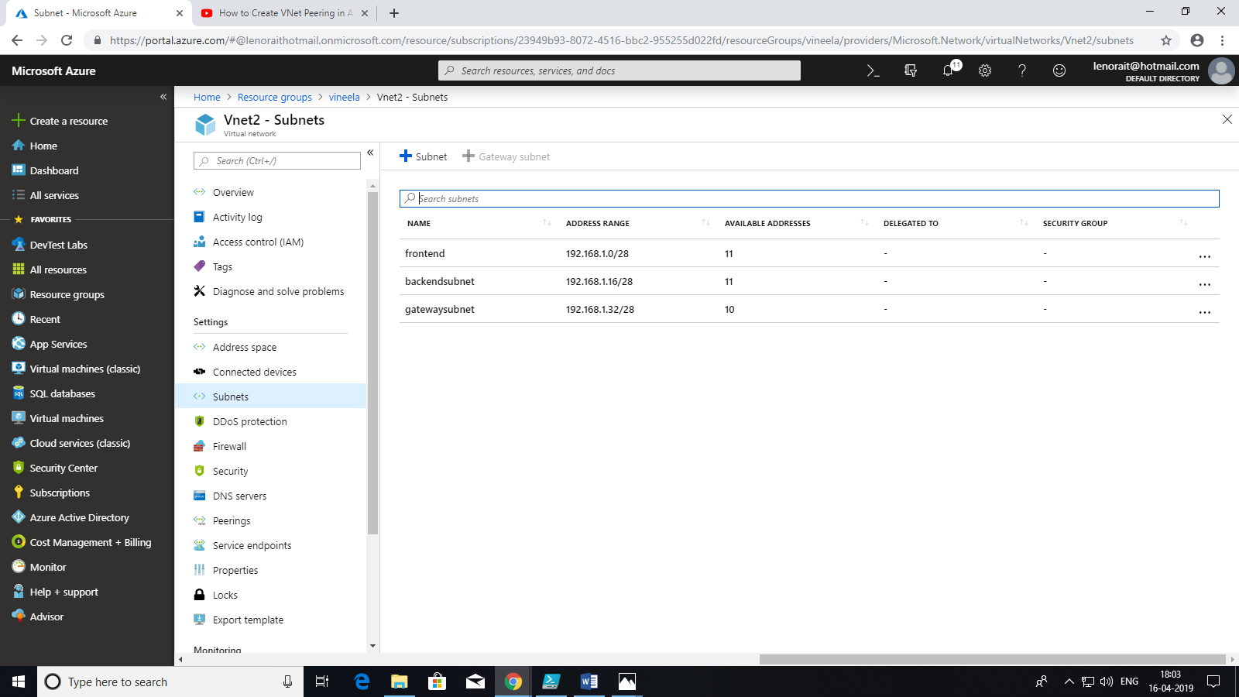

In Vnet3 Creating Subnets And gateway

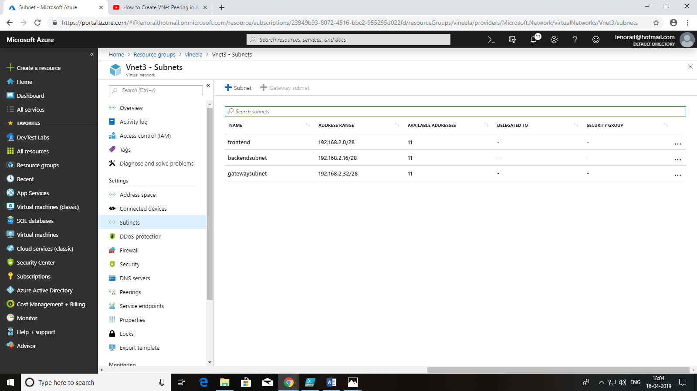

Create Vpn Gateway1

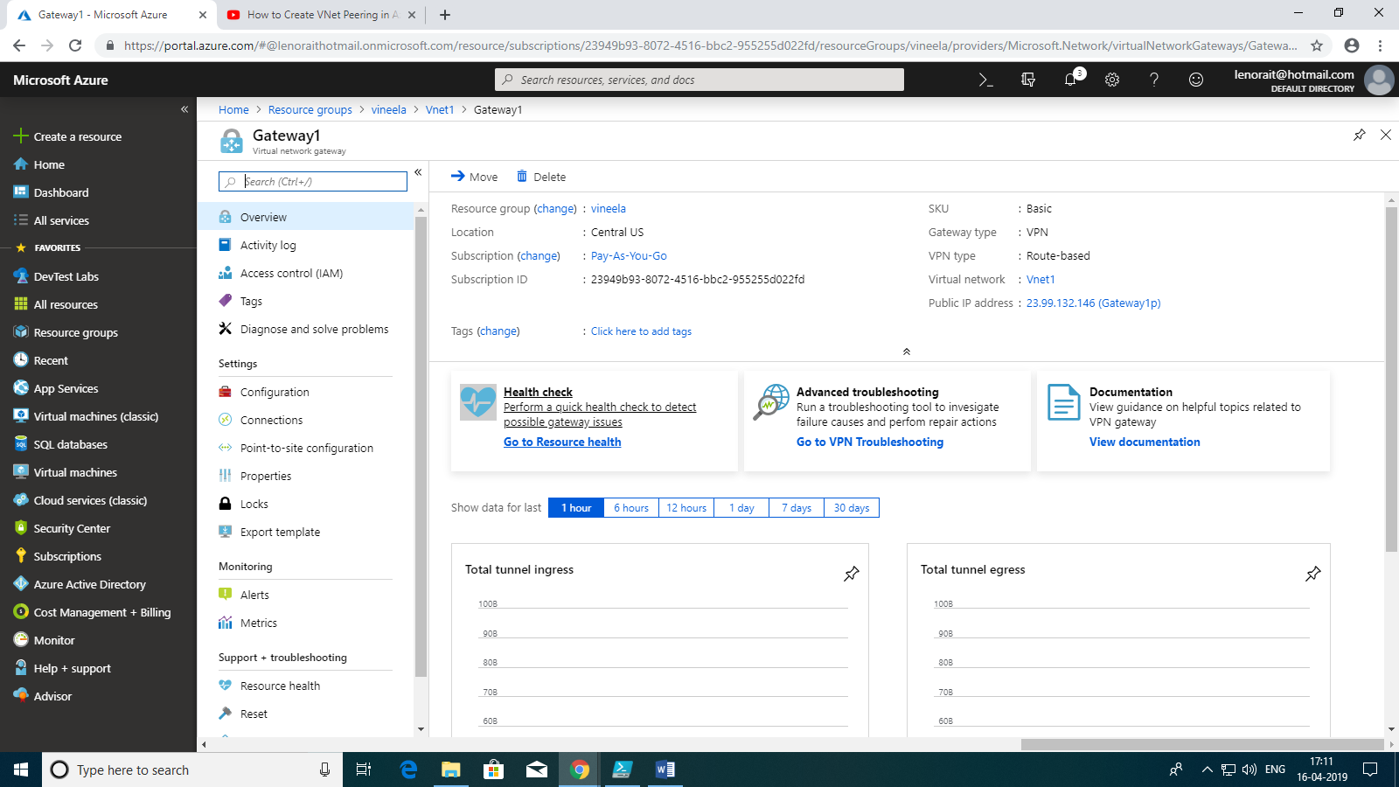

Create VpnGateway2

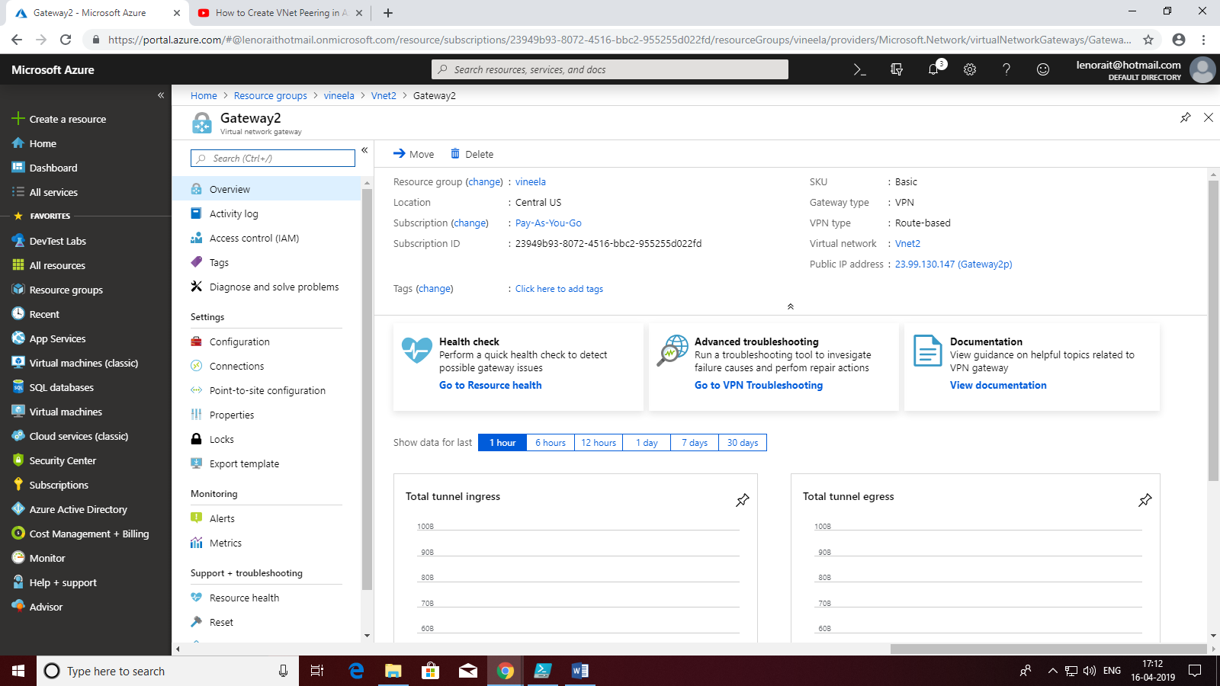

In Gateway1 – Connections

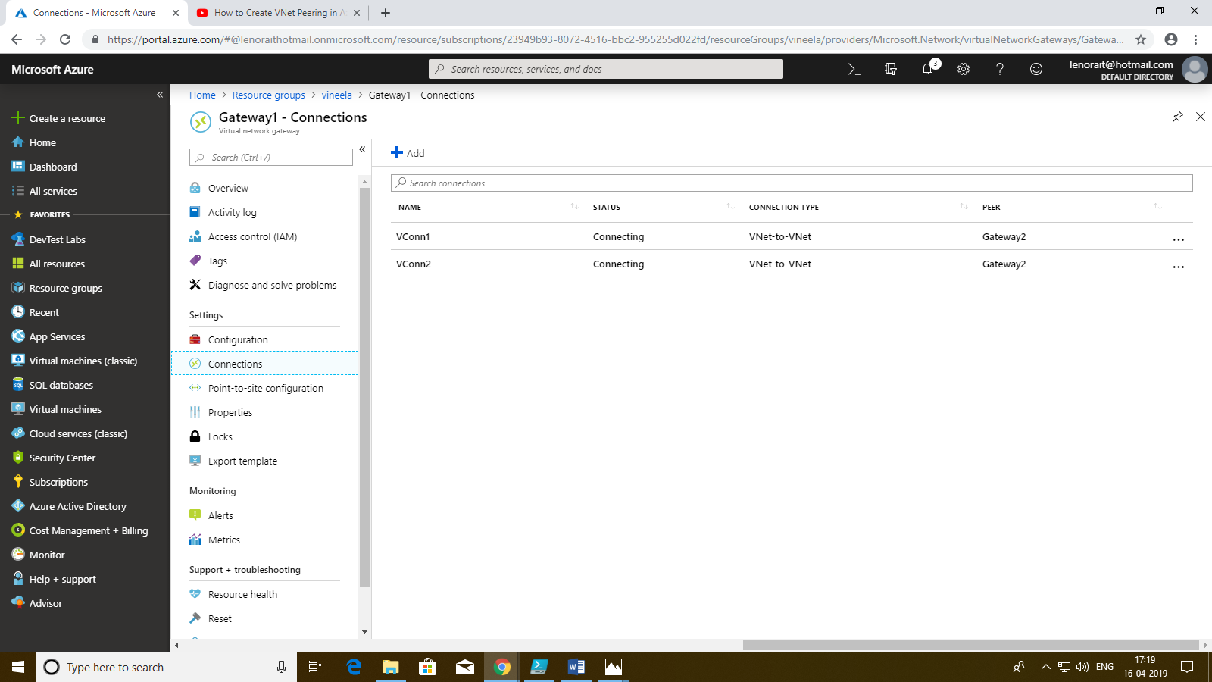

Inside Gateway1 Connections Connect Gateway1-Gateway2 with name Vconn1

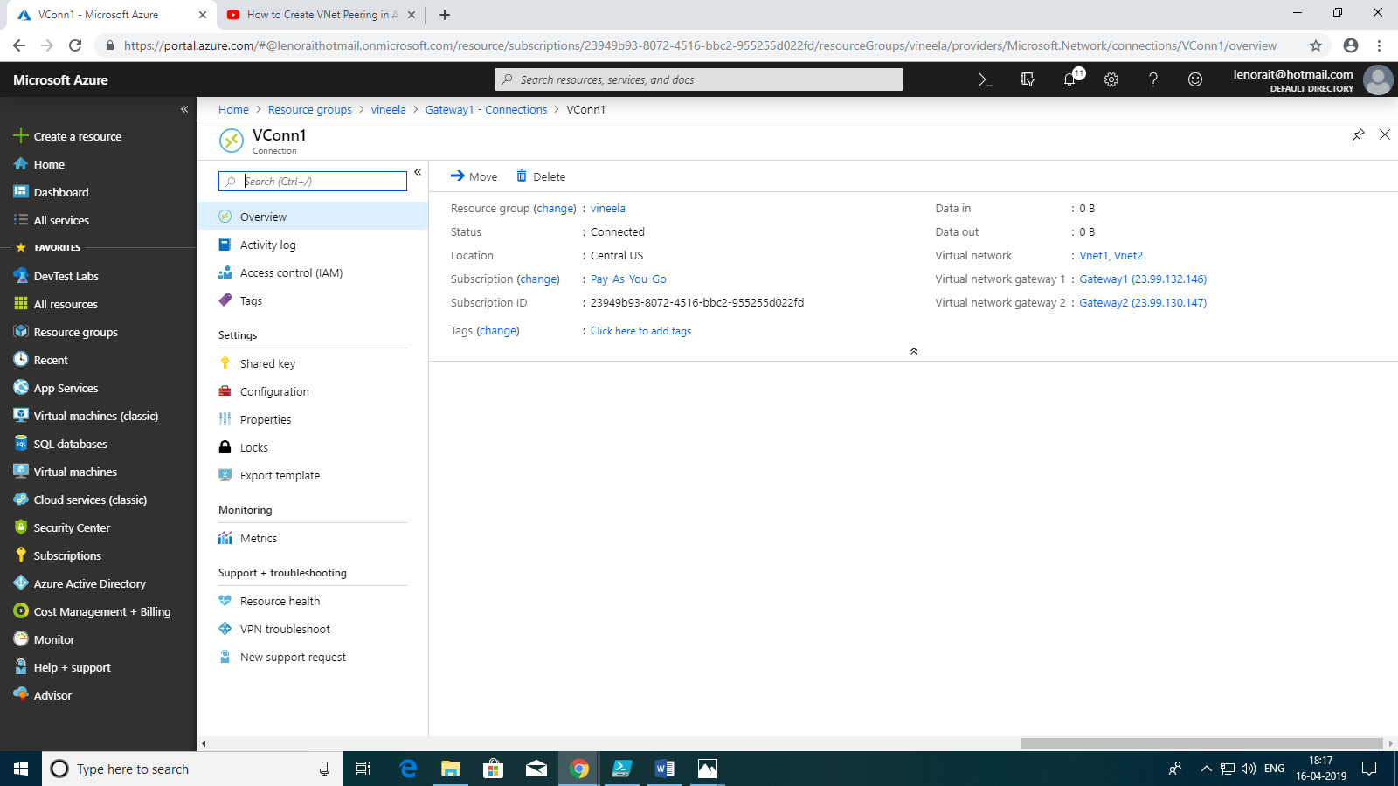

In Gateway2 Create Connections

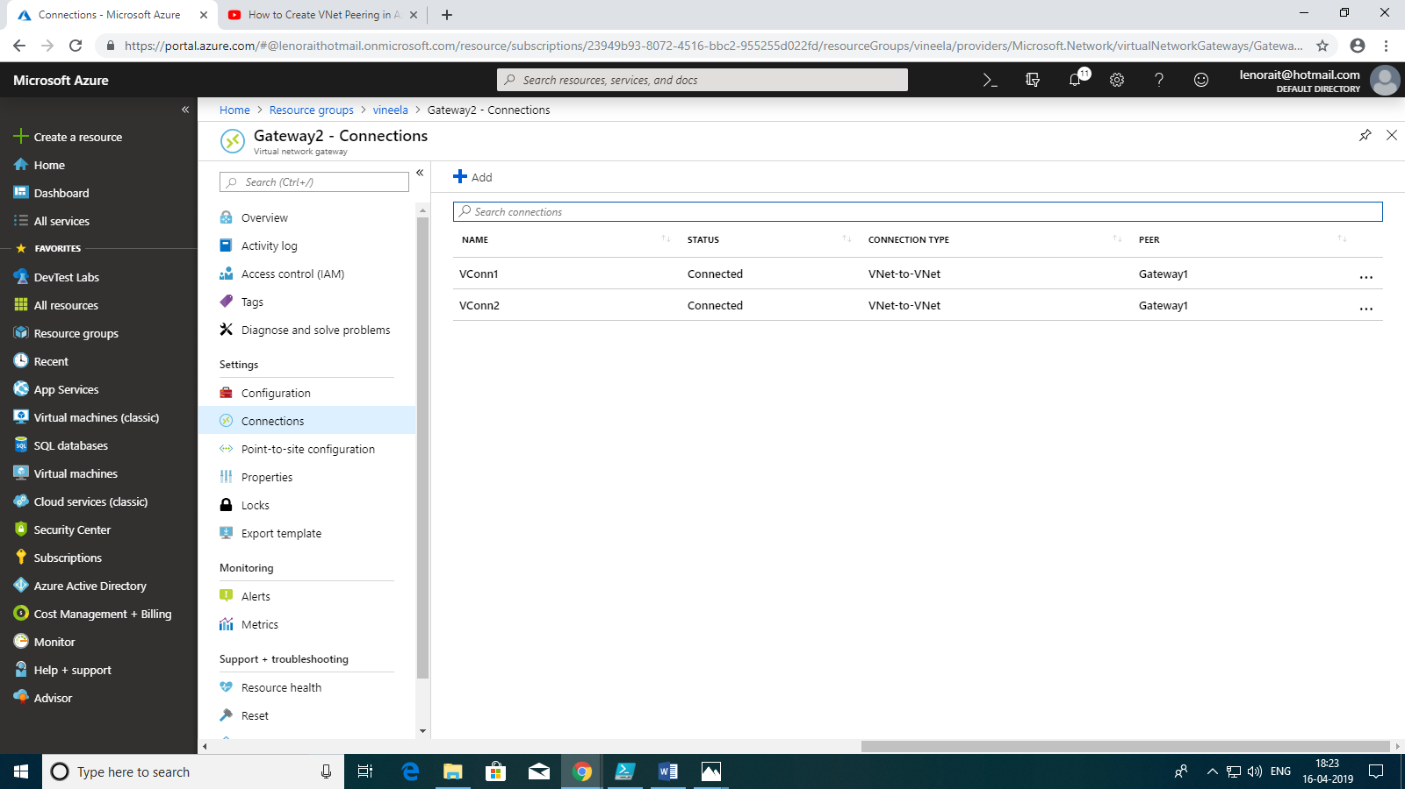

Inside Gateway2 Connections Connect Gateway2-Gateway1 with name Vconn2

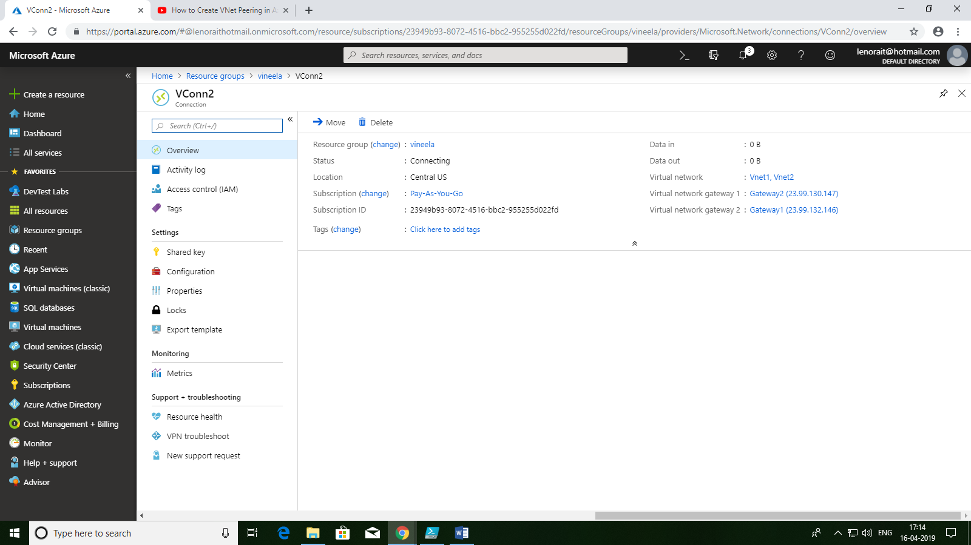

Create Vpn Peering and set this as hub:

In Vnet2 -peerings Named as VnetPeering1(Vnet2-Vnet3)

Vnetpeering1

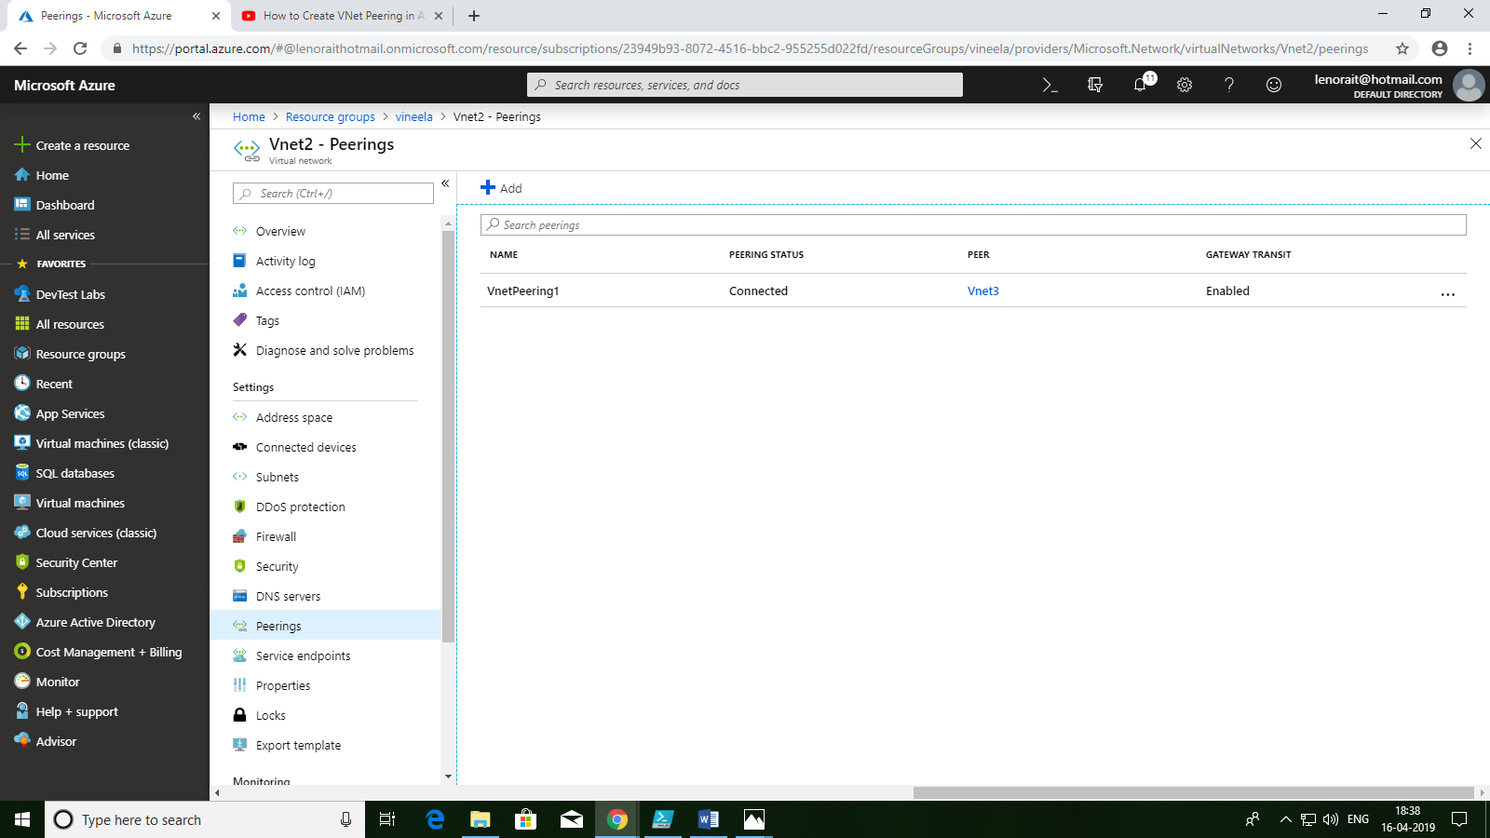

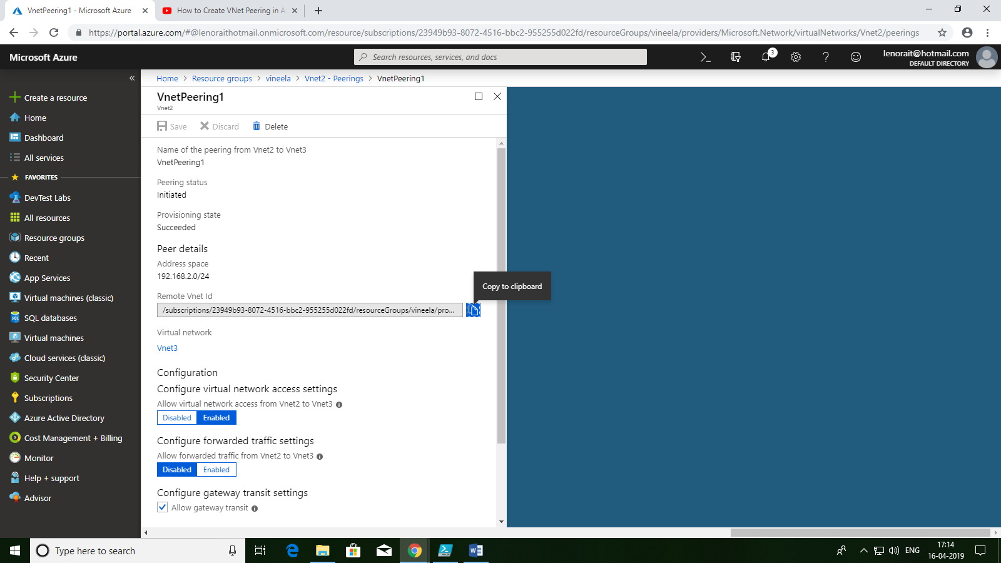

Create Vpn Peering and set this as spoke

In Vnet3-Peerings named as VnetPeering2(Vnet3-Vnet2)

VnetPeering2

